Application Form
Tuesday, 7th – Tuesday, 14th July 2026
CNeuro2026 Theoretical and Computational Neuroscience Summer School
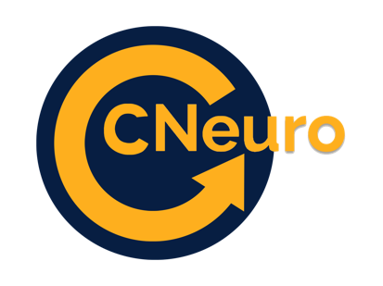
hosted by Tsinghua University in Beijing, China.
To apply, please take the time to fill in the form below. Please submit this together with your CV and any additional documents in a single PDF file to info@cneuro.net by April 1, 2026 at the latest.

Applicant Information
Gender: female male other prefer not to say

Full Name:
 | First | Middle | Last

Phone: |  | Email: | :

Education
University: |  | Bachelor Degree (study field):

From: |  | To: |  | Did you graduate? | YES | NO | Grade Average:

University: |  | Master Degree (study field):

From: |  |  | To: |  | Did you graduate? |  | YES | NO | Grade Average:
University: |  |  |  |  |  | PhD Degree  (study field):

From: |  | To: |  | Did you graduate? | YES | NO | Grade Average:

Other: |  |  |  |  |  | Post-Doctoral Degree  (study field):
From: |  |  | To: |  | Did you graduate? |  | YES | NO |  | Grade Average:

Related Coursework

Please list at least three relevant courses related to the subjects studied at the CNeuro Summer School.

Course 1:
Course 2:
Course 3:
Course 4:
Course 5:

Motivation

Please describe in 5 lines why you are applying for the CNeuro2026 Summer School.

Is there anything else that you would like us to know?

Disclaimer and Signature

I certify that my answers are true and complete to the best of my knowledge.
If this application leads to employment, I understand that false or misleading information in my application may result in my disqualification from attending the CNeuro2026 Summer School.

Signature: |  | Date:

